4.

delimiter //

CREATE TRIGGER dept_update

BEFORE UPDATE ON dept

FOR EACH ROW

BEGIN SET NEW.dname = UPPER(NEW.dname);

END;

//

delimiter ;

5.

ALTER TABLE dept ADD (no_of_employees INT);

6.

UPDATE dept

SET no_of_employees =

(SELECT COUNT(*)

FROM emp

WHERE emp.deptno = dept.deptno);

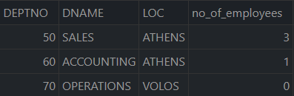

7.

delimiter //

CREATE TRIGGER emp_insert

AFTER INSERT ON emp

FOR EACH ROW

BEGIN

UPDATE dept

SET no_of_employees = IFNULL(no_of_employees, 0) + 1

WHERE deptno= NEW.deptno;

END;

//

delimiter ;

8.

INSERT INTO emp (EMPNO, NAME, DEPTNO) VALUES(7985, 'CLARKE', 70);

SELECT * FROM emp;

SELECT * FROM dept;

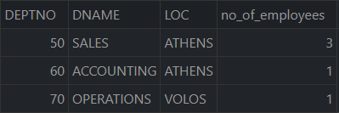

9.

delimiter //

CREATE TRIGGER emp_delete

AFTER DELETE ON emp

FOR EACH ROW

BEGIN

UPDATE dept

SET no_of_employees = IFNULL(no_of_employees, 0) - 1

WHERE deptno= OLD.deptno;

END;

//

delimiter ;

// TESTING //

DELETE FROM EMP WHERE EMPNO='7985';

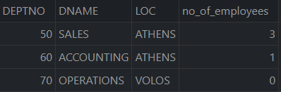

10.

DELIMITER //

CREATE TRIGGER emp_update

AFTER UPDATE ON emp

FOR EACH ROW

BEGIN

INSERT INTO `updates` (`value`) VALUES ('1');

END;

//

DELIMITER ;

